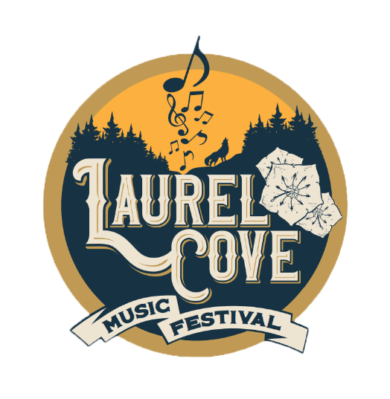
Media Pass Request
Name: ____________________________

Company or Organization: _____________________________________

Type of Media To Be Obtained (Pictures, Video, Audio, etc….): _________________________________

List any past festivals or events you’ve worked:
_____________________________________________________________________________________

List any places (websites, magazines, etc) that your work has been featured:
_____________________________________________________________________________________

Will you be willing to help promote our event on your social media pages: ________________________

Signature: ___________________________________________________

Please send any examples along with this filled out form to jon@bellcountytourism.com
By signing this form, I agree to hold Laurel Cove, along with all its partners, volunteers, sponsors, and all other related entities not liable in the case that any equipment is lost, damaged, or stolen.

